CASE STUDY: Gangster Ganga
Executive Producer | JioHotstar Release
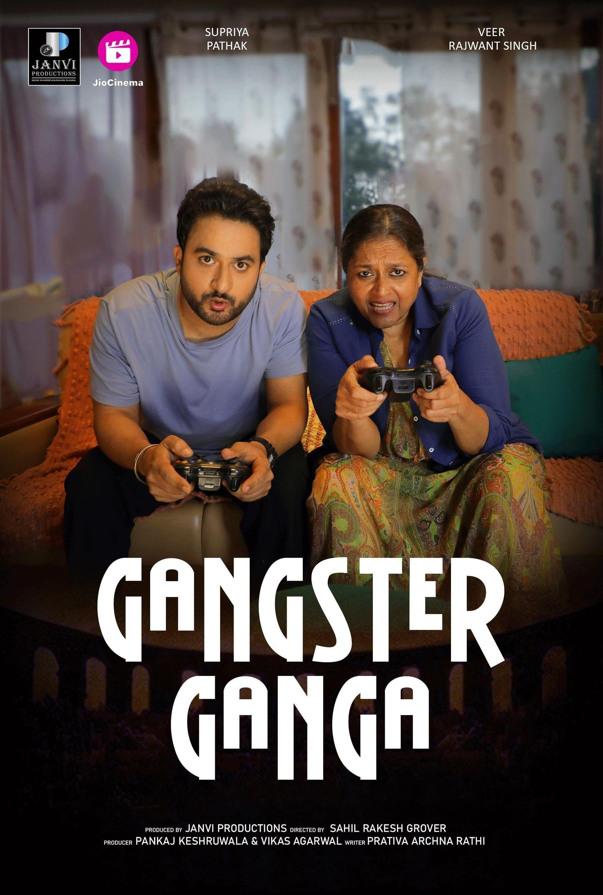

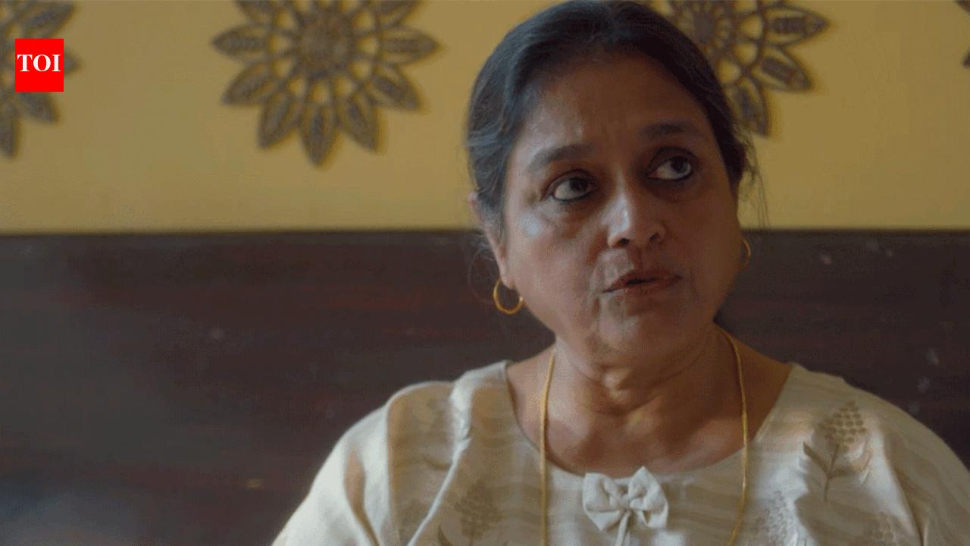
Project Title: Gangster Ganga
Platform: JioHotstar / Hotstar
Role: Executive Producer
Director: Sahil Rakesh Grover
Producer: Vikas Agarwal
Director of Photography: Ashwin Kadamboor
Language: Hindi
Format: Short-Format OTT Film
Release Year: 2023
Estimated Production Budget: ₹1 Crore INR (Approx. £95,000–£100,000 GBP based on 2023 exchange rates)

PROJECT OVERVIEW
Gangster Ganga is a Hindi short-format OTT film released on JioHotstar in 2023, featuring acclaimed actor Supriya Pathak alongside Veer Rajwant Singh. Designed for streaming audiences, the project required a tightly controlled production structure capable of supporting efficient execution, technical consistency, and platform-ready delivery standards within a compressed runtime format.
As Executive Producer, I oversaw the operational and production-management framework supporting the film from active production through to final delivery. My involvement focused on maintaining production continuity, structured execution, workflow efficiency, and delivery discipline across multiple stages of the project lifecycle.
The film is publicly listed on IMDb and JioHotstar, with official release records, promotional material, cast information, and production credits available online. (IMDb)

PRODUCTION CONTEXT
Unlike long-format productions, short-form OTT projects leave very limited room for operational inefficiency. Every production decision directly impacts pacing, screen rhythm, visual consistency, technical quality, and audience engagement.
The project required:
- disciplined scheduling,
- streamlined departmental communication,
- efficient resource utilisation,
- controlled filming operations,
- and seamless coordination between production and post-production.
The objective was not simply to complete the film, but to deliver a polished streaming-ready project aligned with the presentation standards expected by a leading OTT platform.

MY ROLE AS EXECUTIVE PRODUCER
As Executive Producer, I managed the operational framework supporting the production across planning, execution, coordination, and final delivery stages.
My responsibilities included:
- Supporting overall production management and workflow coordination.
- Maintaining scheduling oversight and operational continuity throughout execution.
- Coordinating practical production requirements across departments.
- Supporting resource planning, logistics management, and production efficiency.
- Maintaining alignment between creative direction and practical production realities.
- Monitoring workflow continuity between filming, post-production, and delivery stages.
- Supporting timely completion while maintaining production standards expected for OTT release.
The role required balancing creative support with disciplined production management while ensuring the project remained commercially controlled and operationally stable throughout execution.

SCALE AND SCOPE
The production was executed within an estimated budget of approximately ₹1 Crore INR, equivalent to roughly £95,000–£100,000 GBP based on prevailing 2023 exchange rates.
Publicly available records confirm:
- 2023 digital release on JioHotstar.
- Approximate runtime of 25–26 minutes.
- Official platform listing and streaming availability.
- Public IMDb listing with verified production credits.
- Promotional support through official trailer and platform content releases.
The project required delivering premium OTT presentation standards while operating within tightly controlled production timelines and financial parameters. (IMDb)

CHALLENGES FACED AND SOLUTIONS IMPLEMENTED
One of the primary challenges involved maintaining production efficiency and creative continuity within the compressed structure of a short-format OTT film.
Short-form productions demand extremely precise execution because:
- limited runtime increases pressure on pacing and visual consistency,
- production delays immediately affect delivery timelines,
- and technical inconsistencies become far more visible on-screen.
Additional production challenges included:
- maintaining continuity across restricted shooting schedules,
- coordinating multiple departments within limited turnaround windows,
- balancing creative expectations against practical execution realities,
- and ensuring smooth workflow transition into post-production.
To address these challenges, I implemented a structured production-management approach centred on:
- clear communication channels,
- disciplined scheduling oversight,
- streamlined departmental coordination,
- proactive issue resolution,
- and continuous monitoring of production milestones.
A strong emphasis was placed on maintaining operational alignment between filming and post-production teams, reducing workflow disruption and supporting a smoother finishing process.
This structured approach helped:
- maintain production stability,
- improve coordination efficiency,
- protect delivery timelines,
- and ensure the film remained technically and operationally ready for OTT release.

EXECUTION AND DELIVERY APPROACH
The production was managed with the same operational seriousness and delivery discipline typically associated with larger commercial projects.
My approach focused on:
- maintaining clarity across departments,
- supporting fast and informed decision-making,
- protecting workflow continuity,
- and ensuring production operations remained organised throughout execution.
Close collaboration between the production team, direction department, and technical crew helped maintain the intended visual tone and narrative structure established by director Sahil Rakesh Grover and cinematographer Ashwin Kadamboor.
Particular attention was given to:
- production coordination,
- technical consistency,
- delivery quality,
- and OTT-ready presentation standards.

IMPACT AND OUTCOME
- Successfully delivered a completed OTT film for release on JioHotstar.
- Maintained structured operational oversight across production and delivery stages.
- Supported efficient workflow continuity between production and post-production departments.
- Helped ensure platform-ready technical standards and presentation quality.
- Contributed towards a professionally executed digital release within India’s competitive OTT ecosystem.
The project reinforced my ability to manage compact-format productions with the same level of operational control, accountability, and delivery discipline expected across larger international projects.
IMDb publicly lists the title with a user rating and verified release details, further supporting the project’s digital presence and discoverability online. (IMDb)

VERIFIED PUBLIC RECORDS
The following publicly accessible records verify the project:
- IMDb – Gangster Ganga (2023)
- IMDb Full Cast & Crew
- IMDb Ratings Page
Verified Credits
- Director — Sahil Rakesh Grover
- Producer — Vikas Agarwal
- Director of Photography — Ashwin Kadamboor
- Executive Producer — Umang Agarwal
The attached end-credit screenshot from the film further verifies my credited involvement as Executive Producer.

CLOSING STATEMENT
Gangster Ganga reflects my approach to production leadership: combining operational structure, practical problem-solving, financial discipline, and controlled execution to support efficient delivery within demanding digital production environments.

